Knox Trail Council
Build an Adventure Campaign
Resource Guide for Packs

Pack Resource Guide

- Welcome to Scouting

- Council Background

- Keys to a Successful Recruitment Kickoff
- How to be Successful at Recruitment
- Reasons for a Town-wide Recruitment
- Tools to make you Successful at Recruitment
  - What is Available from Knox Trail Council
  - What is the National Marketing Toolbox
  - How to Place your Unit on the Map
  - Sample Press Releases

- Volunteer Infrastructure and Partnership
- District Membership Committee (Structure and Descriptions)
- Unit Committee (Structure and Descriptions)
- Commissioner Staff in Membership and Unit service plan

- Execution Plan and Backdating Schedule
- January through December

- Summary

Attachments:
Unit Membership Committee
- Peer-to-Peer Recruiting Coordinator
- Unit Spring Recruitment Coordinator
- Unit Fall Recruitment Coordinator
- Transition Coordinator

- Welcome to Scouting

Scouts do stuff. They build things. Play with purpose. Make friends and work together. Set goals and clear them. They go places. Physically. Mentally. Spiritually. These life-changing experiences — and the confidence they provide — become bricks in the wall of childhood. Bricks that eventually form a foundation. One a Scout can stand on to embrace opportunity and overcome obstacles. For the parents watching in awe, it’s not a question of where their Scout will go, but where won’t he go.

As we celebrate more than 105 years of Scouting in America, the Knox Trail Council extends a warm welcome to you, our newest family in the Scouting program, and here in the Metrowest area. We have had quiet an adventure and we are looking to make the future even greater!

And that is why we have created this membership plan to build a greater future. The Build an Adventure campaign is a national campaign started in 2014, with its inviting, aspirational, and fun imagery which helps parents understand that Scouting makes the most of the little time they have to impact the lives of their children, while appealing to youth using fun, family, and friends.

You have just joined a vibrant, dynamic, and growing program which has the collective support of hundreds of community organizations, institutions, chartered partners, and dozens of other youth-serving agencies. Scouting works!

The Knox Trail Council is grateful for the excellent support we receive from existing families in terms of time, talents, and finances. Those who have come before you have laid the foundation for YOU – today – so that your children can enjoy Scouting.

We trust that you will do your part, in whatever way you can, for the kids of tomorrow.

Welcome to the Scouting Family! Enjoy the adventure.

Yours in Scouting,

Sherry E. Bowden, Council President Mark I. Niedzielski, Council Commissioner

Matthew J. Budz, Scout Executive/CEO

- Council Background

The Knox Trail Council was established in 1996 and is the result of a consolidation of Scouting programing that has served Greater Metrowest for nearly a century. The Council’s name is derived from the name of the path that was used by General Henry Knox in the spring of 1776 to bring a train of artillery, captured at Fort Ticonderoga, NY to General George Washington in Boston, MA during the Revolutionary War. This trail passes through the Council’s footprint and is even preserved in its original state within one of our camping facilities.

Today, our Council serves thousands of youth and is managing two excellent camping properties: the Nobscot Scout Reservation in Framingham/Sudbury, MA and the Robsham Scout Reservation in Bolton, MA. Combined, they constitute over 800 acres of beautiful forested land and open space, making each one into a true ‘Urban Oasis’.

The Council’s Mission Statement is:
“… to prepare young people to make ethical and moral choices over their lifetimes by instilling in them the values of the Scout Oath and Law.”

The Council’s Purpose is:
“… to provide the program support needed by the volunteer leaders of the various Cub Scout Packs, Boy Scout Troops, Venture Crews, Explorer Posts and Learning for Life Groups in the communities we serve in the Metro Area.”

Council Territory

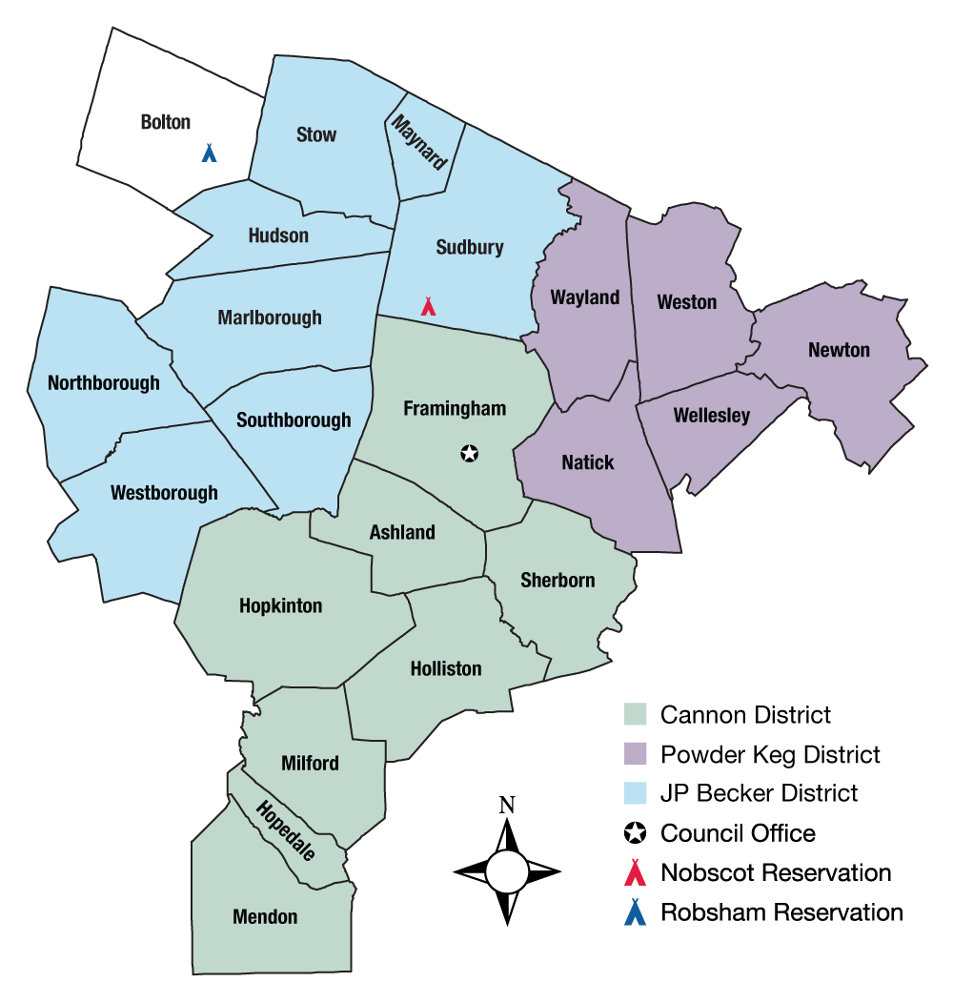

The Knox Trail Council serves 21 cities and towns in the Greater Metrowest region of Eastern Massachusetts. This overall territory is divided into three distinct areas, known as Districts, to ensure resources are evenly distributed amongst the Council’s constituent communities.

Cannon District: Ashland, Framingham, Holliston, Hopkinton, Hopedale, Mendon, Milford, and Sherborn.
Powder Keg District: Natick, Newton, Wayland, Wellesley, and Weston.
JP Becker District: Hudson, Marlborough, Maynard, Northborough, Southborough, Sudbury, Stow, and Westborough.

- Keys to a Successful Recruitment Kickoff

How to be Successful at Recruitment
A successful recruitment effort is as easy as setting a goal, making a plan and carrying it out. The purpose of this membership plan is to help set you up for success.

At the beginning of the year, Council will provide each unit with a target recruitment goal. This is developed for unit leaders so that they do not have to spend time crunching the numbers and instead focus on spreading the message of Scouting and getting youth involved in fun programs.

Units are then encouraged to incorporate the components of this plan in their calendar for the year. Many of those strategies overlap with other Scouting events and activities to provide for a smooth execution of the plan. Included in that is hosting both a spring and fall recruitment drive to ensure that Scouting remains a prominent and viable options for youth who might otherwise consider another program that is recruiting during either season.

Track your efforts and continue to evaluate opportunities for growth within your community. The best way to do this is by designating a parent volunteer to focus on membership and report on it at monthly committee meetings, which is a key goal of the overall plan.

Reasons for a Townwide Recruitment

The Council has embraced townwide recruitment as a means to ensure that youth have the best opportunity to join Scouting. Units are encouraged to organize on a townwide recruitment night so that youth have one place to learn about Scouting, become acquainted with the various units, and make a choice on the one that would be the best fit. Moreover, townwide recruitment enables units to combine resources and prevent any unnecessary duplication in recruitment. The power of the Scouting movement is that we have strength in numbers, and that can be applied to recruiting at the local level.

Tools to make you Successful at Recruitment

You do not need to reinvent the wheel in order to launch a successful recruitment campaign. In fact, everything you need is just a click away. First, the Council is armed with a host of recruitment materials from flyers to signs. Contact your district executive for a “recruitment” box, which are distributed at Spring and Fall recruitment launches. Secondly, visit Scouting.org or the Scouting Wire for a host of best practices, plans and materials to assist in planning your effort and executing it. There you will find resources to launch proven recruitment efforts like Rocket into Scouting. Third, make sure your unit is listed on the BeAScout.org website, and the information is up-to-date. This is a way that families who are unfamiliar with unit leadership may be able to contact the appropriate leader to get involved. Lastly, and most importantly, communicate with fellow local Scouters, your commissioner or professional staff if you get stuck. Scouting has endured for more than a century, and there is plenty of institutional knowledge to help you succeed in recruitment.

What is Available from Knox Trail Council

Knox Trail Council is armed with a host of recruitment materials from flyers to yard signs. Contact your district executive for a “recruitment” box, which are distributed at each Spring and Fall recruitment launch.

What is the National Marketing Toolbox

One important outcome of the Build an Adventure campaign was the development of new national marketing toolbox that supply unit leaders with all the recruitment materials that help communicate the value of Scouting to parents. This one-stop marketing toolbox has all the tools and materials you will need for a successful recruitment event. All of the Boy Scout of America’s most current marketing tools and resources can be found on the Marketing Toolbox at www.scouting.org/marketing.

How to Place your Unit on the Map

BeAScout.org is the application that puts your Pack, Troop or Crew on the map! Potential Scouts and volunteers can go to BeAScout.org and find Scouting in their neighborhood. If your unit’s pin is up to date they will find you!
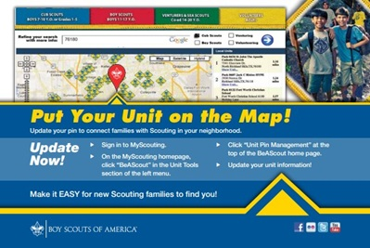
- Raise Your Pack, Troop or Crew’s Profile in the Community
- Recruit More Youth and Volunteers and Help Grow Scouting
- Customize your Google ‘pin’ with contact information, photo, special message and even your unit Web site.

Follow these simple steps to update your pin.

Cubmasters, Scoutmasters, pack and troop committee chairs:

- Sign in to My.Scouting.org.
- On the My.Scouting homepage, click “BeAScout” in the Unit Tools section of the left menu.
- Click “Unit Pin Management” at the top of the BeAScout Homepage.
- Update your unit information.
- Additional support can be found at http://www.scouting.org/scoutsource/Membership/Youth_Recruitment.aspx

Sample Press Releases

Press Release Template No. 1

For Immediate Release

Join the Fun! Join Cub Scouting!
Cub Scouting wants you! Now is the time to join the fun and excitement of America’s foremost youth program for boys — Cub Scouting. Sign-up nights will be held throughout the week of ____________________.

Designed for boys ages 7 to 10, Cub Scouting combines outdoor activities, sports, academics, and more in a fun and exciting program that helps families teach ideals such as honesty, good citizenship, and respect.

Cub Scout packs will hold roundups for Scouting at elementary schools and other locations throughout the area during the next ____________________. Flyers with additional details will be distributed at schools before the scheduled roundups. Interested boys and parents are encouraged to attend a meeting in their neighborhood.

Cub Scout roundups are scheduled at the following locations:

The Boy Scouts of America comprises more than one million volunteers working together for the sole purpose of helping its nearly three million youth succeed in life.
For more information, contact ____________________.

Press Release Template No. 2

For Immediate Release

Join the Fun! Join Cub Scouting! Cub Scouting wants you! Now is the time to join the fun and excitement of America’s foremost youth program for boys — Cub Scouting. A sign-up night will be held on ____________________ at ____________________. Flyers with additional details will be distributed at school.

Designed for boys ages 7 to 10, Cub Scouting combines outdoor activities, sports, academics, and more in a fun and exciting program that helps families teach ideals such as honesty, good citizenship, and respect.

The Boy Scouts of America comprises more than one million volunteers working together for the sole purpose of helping its nearly three million youth succeed in life.
For more information, contact ____________________.

- Volunteer Infrastructure and Partnership

Unit Committee

The structure of a Pack Committee is dependent on the size of the Pack. It is critical to the continued success of a Scouting unit to have dedicated positons of responsibility for unit recruitment.

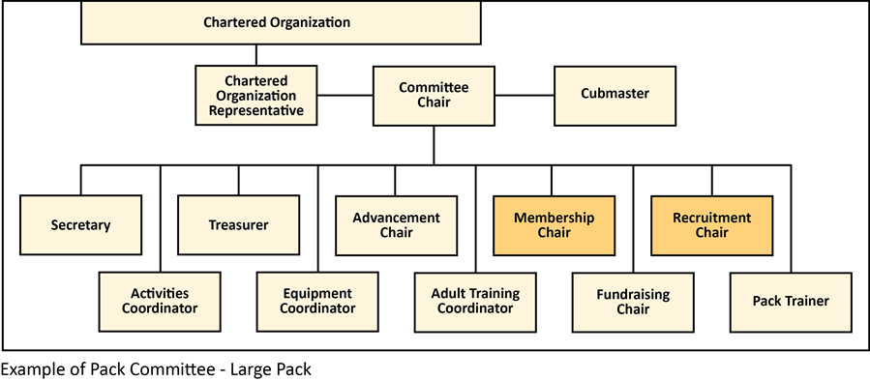

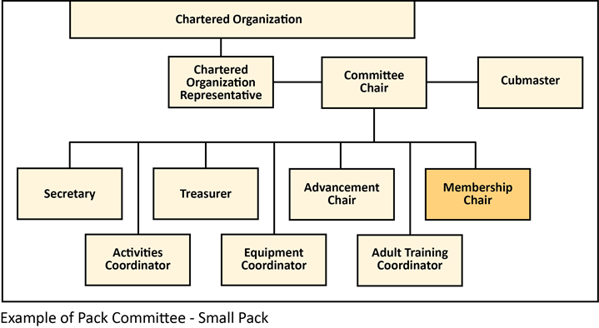

Unit Membership Chair

The Membership Chair is appointed by the Committee Chair to help ensure a smooth transition of new Scouts into the Troop and orientation for new parents. Responsible for recruiting campaigns and for year-round recruitment, growth and retention.
Unit Membership Committee

The Membership Committee consists of parent volunteers assigned to specific responsibilities or annual recruiting events. This structure allows for more focused leadership and encourages the involvement of more adult volunteers in limited roles. The possibilities are endless, as we continue the transition to the “volunteer-driven, professionally guided” membership team.

At the unit level, we urge each unit to fill the following positions:
- Peer-to-Peer Recruiting Coordinator
- Unit Spring Recruitment Coordinator
- Unit Fall Recruitment Coordinator
- Transition Coordinator

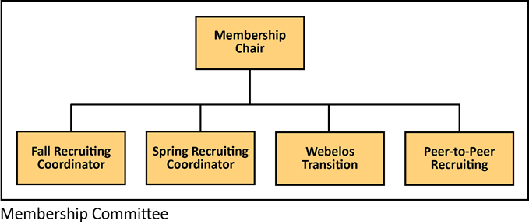

- Execution Plan and Backdating Schedule

The Backdating Schedule is a tool that units can use to plan their monthly membership activities. This schedule lists the months in which the tasks should be accomplished; we suggest that the work on all tasks be undertaken six months prior to the completion date. This is intended as a guide; units may alter dates per their own needs, realizing that individual unit schedules may differ from the national model.

Key:
C: Cub Scout Recruitment (Spring and Fall)
T: Training Opportunity for Leaders

January
Item | Program
Review Council Membership Plan; Update where needed and share with local units. | C
Basic Training for Leaders. | T

February
Item | Program
Conduct summer camp orientation to encourage Cub Scout involvement. | C
Basic Training for Leaders. | T

March
Item | Program
Recruit Pack Membership Chair for School Nights | C
Conduct summer camp orientation to encourage Cub Scout involvement. | C
Basic Training for Leaders. | T

April
Item | Program
Participate in the Annual STEM Academy at Nobscot. | C
Set town meetings for Join Scouting Nights – work with other units in town. | C
Conduct summer camp orientation to encourage Cub Scout involvement. | C
Basic Training for Leaders. | T

May
Item | Program
Participate in Pawsox Overnight Activity | C
Submit flyers for approval from school/ superintendent’s office. | C
Email flyers to district executive to be printed and delivered. | C
Host Joining Scouting Night at local schools or central location in town. | C
Basic Training for Leaders. | T

June
Item | Program
Attend Program Launch at the Fay School. | C
Participate in council’s Annual Spring Taste of Scouting event. | C
Order yard signs. | C
Order flyers for Cub Scout, Boy Scout and Venture Crews. | C
Order recruitment material for Fall Recruitment Boxes for units. | C

July
Item | Program
Order all in-house materials for School Nights, recruitment boxes, fall event postcards – Taste of Scouting, Fall Camporee, Adventure Day Camp | C
Order Y and A applications, mini Boys’ Life magazines, etc. | C

August
Item | Program
Hold Join Scouting Night Kickoff at Nobscot. | C, T
Set town meetings for Join Scouting Nights – work with other units in town. | C

September
Item | Program
Take press releases to local radio, TV, newspaper outlets. | C
Submit flyers for approval from school/ superintendent’s office. | C
Email flyers to district executive to be printed and delivered. | C
Host Joining Scouting Night at local schools or central location in town. | C
Make sure new leaders get trained and attend September Scout events. | C
Basic Training for Leaders | T

October
Item | Program
Make sure School Nights are happening. | C
Secure school and classroom access for meeting locations. | C
Participate in council’s Annual Fall Taste of Scouting event. | C
Basic Training for Leaders. | T

November
Item | Program
Recharter unit using online system. | C
Basic Training for Leaders. | T

December
Item | Program
Recharter unit using online system. | C
Conduct health assessments of all units. | C
Basic Training for Leaders. | T

- Summary

Execution and Implementation

This plan should be reviewed at the district level and be ready for implementation in January 2016. The District Chair, through the Council Vice President for District Operations, is responsible for ensuring that districts follow the strategies and timetables outlined in this plan.

District Membership Chairs will report back to the Council Membership & Relations Committee during quarterly membership committee meeting/conference call on their progress towards their individual district goal as listed in the council strategic plan.

Comments from the District Chairs and Vice Chairs, Membership on the provisions of this plan are welcome at any time. Comments should be directed to Sean Riley, Vice President, Membership & Relations, at seanriley05@gmail.com.

The Council VP, Membership & Relations is responsible to review this plan quarterly and revising it as needed.

